**Find the measurement indicated in each parallelogram.**

|  |  |  |
| --- | --- | --- |
| 1. | 2. | 3. |
| 4. | 5. | 6. |

**Solve for the variable. Each figure is a Parallelogram.**

|  |  |  |
| --- | --- | --- |
| 7. | 8. | 9. |
| 10. | 11. | 12. |

Find the measures of the numbered angles for each parallelogram**.**

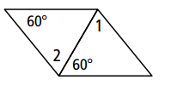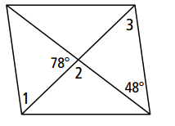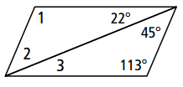13. 14. 15.

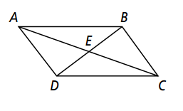



16. AE *= x +* 5*,* EC *= y,* DE *=* 2x*+*3*,* EB*= y +* 2

17. AE = 3*x*, EC = 2y – 2, DE = 5x, EB = 2y + 2

**Find the measures of the numbered angles in each rhombus.**

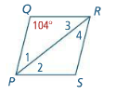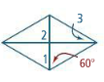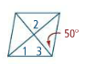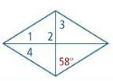18. 19. 20. 21.

22. Find the given lengths in the rhombus below.

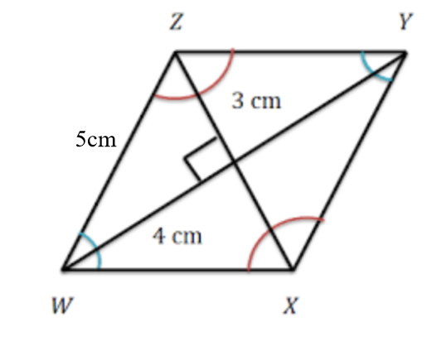

$\overline{ZY}=$

$\overline{XZ}=$

$\overline{WY}=$

$\overline{WX}=$

1. ___________
2. ___________
3. ___________
4. ___________

**LMNO is a rectangle. Find the following.**

For 23 and 24. Find the value of x and the length of each diagonal.

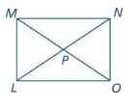

23. 

24. *LN =* 3*x +* 1 and *MO* = 8*x* – 4

25. Find the measure of ________

26. Given the measure of $∠NMO$ is 32⁰.

a) Find the measure of $∠LMO$

_________

b) Find the measure of _________

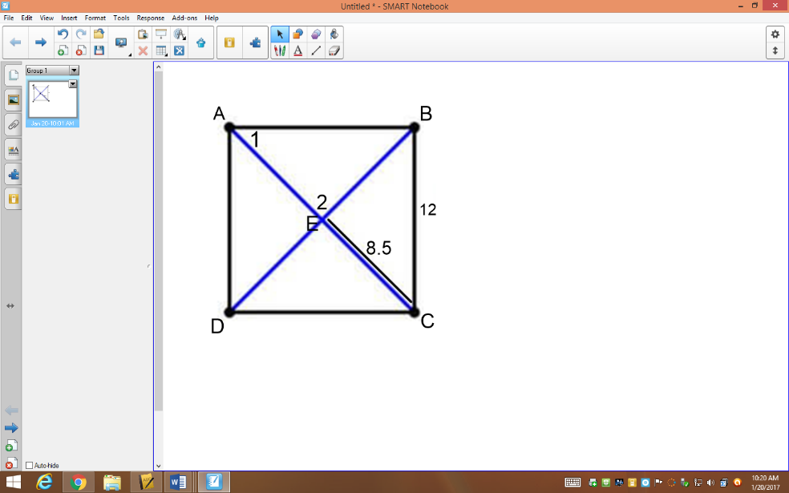

27. ABCD is a square.

a) Find the measure of angle 2.

b) Find the measure of angle 1.

c) Find the length of side AB.

d) Find the length of DB.

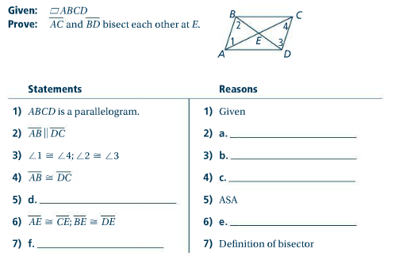28.

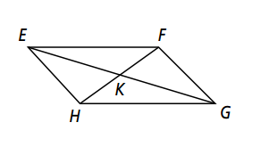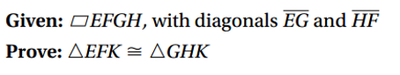29. Complete this two column proof:

|  |  |
| --- | --- |
| Statements | Reason |
| 1. | Given |
| 2. | The diagonals of a parallelogram bisect each other. |
|  | 4. |
| 3. | 5. |

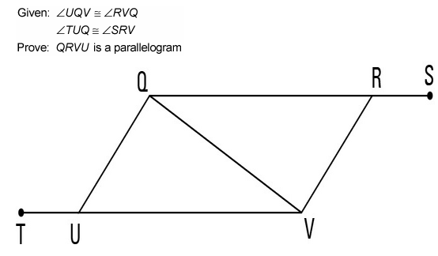

30. Given: 



Prove:  is a parallelogram

|  |  |
| --- | --- |
| Statement | Reason |
| 1. | 1. |
| 2. | 2. |
| 3. | 3. |
| 4. | 4. |
| 5. | 5. |
| 6. | 6. |
| 7. | 7. |
| 8. | 8. |
| 9.  is a parallelogram | 9. |

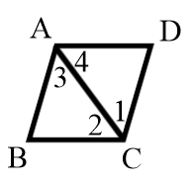

31. Given:  is a parallelogram

 bisects 

Prove: is a rhombus

|  |  |
| --- | --- |
| Statement | Reason |
| 1.  bisects | 1. |
| 2. | 2. |
| 3. | 3. |
| 4. | 4. |
| 5. | 5. |
| 6.  is a parallelogram | 6. |
| 7. | 7. |
| 8. | 8. |
| 9. is a rhombus | 9. |



32. Given:  is a rhombus

Prove:  bisects 

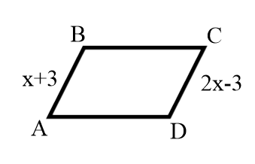

|  |  |
| --- | --- |
| Statement | Reason |
| 1.  is a rhombus | 1. |
| 2. | 2. |
| 3. | 3. |
| 4. | 4. |
| 5.  and | 5. |
| 6.  bisects | 6. |

33. Given:  is a parallelogram

Prove: 

|  |  |
| --- | --- |
| Statement | Reason |
| 1.  is a parallelogram | 1. |
| 2. | 2. |
| 3. | 3. |
| 4. | 4. |
| 5. | 5. |
| 6. | 6. |
| 7. | 7. |

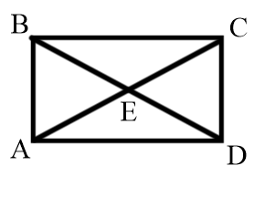34. Given:  is a rectangle





Prove: 

|  |  |
| --- | --- |
| Statement | Reason |
| 1.  is a rectangle | 1. |
| 2. | 2. |
| 3. | 3. |
| 4. , | 4. |
| 5. | 5. |
| 6. | 6. |
| 7. | 7. |
| 8. | 8. |

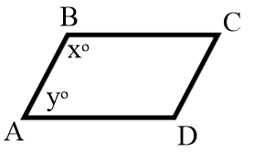

35. Given:  and 

Prove:  is a parallelogram

|  |  |
| --- | --- |
| Statement | Reason |
| 1.  and | 1. |
| 2. | 2. |
| 3. | 3. |
| 4. | 4. |
| 5. | 5. |
| 6.  are supplementary  are supplementary | 6. |
| 7. | 7. |
| 8.  is a parallelogram | 8. |