Math 1B Final Exam Review DO NOT WRITE ON THIS REVIEW

Multiple Choice. Pick the most appropriate response.

1. If $f\left(x\right)=\frac{1}{4}{\left(4\right)}^{x}$ then find $f\left(5\right)$.

a) 1024 b) 256 c) 64 d) 16

2. What is the domain of $y=5^{x-2}+7$ ?

a) $\left(-∞,∞\right)$ b) $\left(-∞,7\right)$ c) $\left(7,∞\right)$ d) $\left(-∞,7\right)∪\left(7,∞\right)$

3. What is the range of $y=5^{x-2}+7$ ?

a) $\left(-∞,∞\right)$ b) $\left(-∞,7\right)$ c) $\left(7,∞\right)$ d) $\left(-∞,7\right)∪\left(7,∞\right)$

4. How much will you have in a savings account if you deposit $2000 at 2% annual interest compounded quarterly for 5 years? $A=P{\left(1+\frac{r}{n}\right)}^{nt}$

a) $6,650,513.46 b) $5,306.60 c) $2,209.79 d) $2020.10

5. Solve. $7^{x-2}=7^{6}$

a) 8 b) 7 c) 6 d) 5

6. Solve. $4^{x+1}=\frac{1}{64}$

a) 3 b) -3 c) 4 d) -4

7. What are the next three terms of the geometric sequence 81, -27, 9, -3 …

a) 0, $-\frac{1}{3} , \frac{1}{6}$ b) $0 , -\frac{1}{3} , \frac{1}{9}$ c) $1 , -\frac{1}{3} , \frac{1}{6}$ d) $1 , -\frac{1}{3} , \frac{1}{9}$

8. Write an explicit rule for the geometric sequence 2, 8, 32, 128, …

a) $a_{n}=2^{n}$ b) $a_{n}=2^{n-1}$ c) $a_{n}={2\left(4\right)}^{n}$ d) $a_{n}={2\left(4\right)}^{n-1}$

9. Write a recursive rule for the arithmetic sequence 25, 15, 5, …

a) $a_{1}=25; a_{n}=a_{n-1}-10$ b) $a_{1}=25; a_{n}=a_{n-1}-5$
c) $a_{1}=25; a_{n}=a_{n-2}-10$ c) $a_{1}=25; a_{n-1}=a_{n}-10$

10. Write the first four terms of the sequence. $a_{1}=8; a_{n}=a_{n-1}+3$

a) 8, 5, 2, -1 b) 8, 9, 10, 11 c) 8, 7, 6, 5 d) 8, 11, 14, 17

11. Construct a perpendicular bisector of a segment. Place the steps in the correct order.
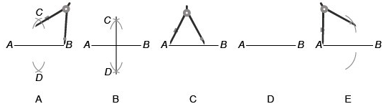

a) A, B, C, D, E b) C, D, E, A, B c) B, A, E, C, D d) D, C, E, A, B

12. Find the coordinates of the midpoint of the segment with endpoints $\left(-10,-4\right)$ and $\left(14,6\right)$.

a) $\left(2,1\right)$ b) $\left(12,5\right)$ c) $\left(1,2\right)$ d) $\left(5,12\right)$

13. Find the length of the segment with endpoints $\left(-10,-4\right)$ and $\left(14,6\right)$.

a) $2\sqrt{5}$ b) 26 c) 13 d) $\sqrt{5}$
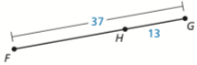
14. Find the length of $\overset{̿}{FH}$.

a) 37 b) 13 c) 50 d) 24
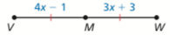
15. M is the midpoint of $\overset{̿}{VW}$. Find the length of $\overset{̿}{MW}$.

a) 4 b) 15 c) 19 d) 11

16. Construct a hexagon inscribed in a circle. Place the steps in the correct order.
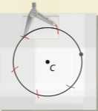
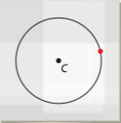
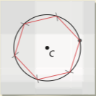
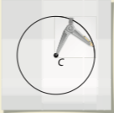
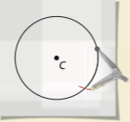

A B C D E

a) A,B,C,D,E b) C,E,D,B,A c) B,D,A,E,C d) D,B,E,A,C

In problems 17 & 18, use the protractor to find the angle measure.
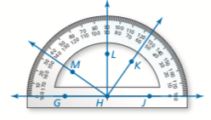
17. m$∠LHK$.

a) $35°$ b) $55°$ c) $125°$ d) $90°$

18. m$∠GHK$.

a) $35°$ b) $55°$ c) $125°$ d) $90°$
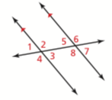
In problems 19 – 22, give the names of the angles.

19. $∠1$ and $∠3$.

a) corresponding b) alternate interior c) alternate exterior d) vertical angles

20. $∠6$ and $∠2$.

a) corresponding b) alternate interior c) alternate exterior d) vertical angles

21. $∠6$ and $∠4$.

a) corresponding b) alternate interior c) alternate exterior d) vertical angles

22. $∠5$ and $∠3$.

a) corresponding b) alternate interior c) alternate exterior d) vertical angles

In problems 23 and 24, use the figure at the right.
23. How many lines of symmetry does the figure have?

a) 0 b) 1 c) 3 d) 5

24. Describe the rotations that map the figure onto itself.

a) $90°, 180°$ b) $72°, 144°$ c) $36°, 72°, 108°, 144°$ d) There aren’t any
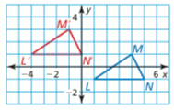
25. What is the rule for the translation of $∆LMN to ∆L'M'N'$?

a) $〈-5,2〉$ b) $〈5,-2〉$ c) $〈-2,5〉$ d) $〈2,-5〉$

26. If you rotated the point $\left(3,2\right) 90°$ counterclockwise the new point would be:

a) $\left(-3,2\right)$ b) $\left(3,-2\right)$ c) $\left(-2,3\right)$ d) $\left(2,-3\right)$
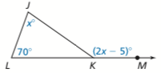
27. Find the measure of the exterior angle in the figure at the right.

a) $75°$ b) $145°$ c) $150°$ d) $225°$
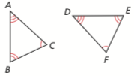
28. Which is the correct congruence statement for the congruent triangles.

a) $∆ABC≅∆EFD$ b) $∆ABC≅∆FED$ c) $∆FDE≅∆CAB$ d) None of these

29. Solve the matrix equation. $\left[\begin{matrix}3 & 2 \\ 1 & -1\end{matrix}\right]\left[\begin{matrix}x \\ y\end{matrix}\right]=\left[\begin{matrix}14 \\ -2\end{matrix}\right]$

a) $x=2, y=4$ b) $x=4, y=2$ c) $x=6, y=-2$ d) $x=-2, y=2$
Free Response. SHOW YOUR WORK if you expect to receive full or partial credit.

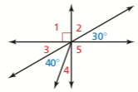
30. Find all the unknown angle measures.

m$∠1=$
m$∠2=$
m$∠3=$
m$∠4=$
m$∠5=$

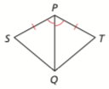
31. Matching. Place the letter of the reason in the space provided.
Given: $\overset{̿}{SP}≅\overset{̿}{TP}, \overset{̿}{PQ} bisects ∠SPT$
Prove: $∆SPQ≅∆TPQ$

Statements | Reasons
1. $\overset{̿}{SP}≅\overset{̿}{TP}$ | 1.______ a. Given
$\overset{̿}{PQ} bisects ∠SPT$ | b. Alternate Interior Angles
2. $∠SPQ≅∠TPQ$ | 2.______ c. Reflexive Property
3. $\overset{̿}{PQ}≅\overset{̿}{PQ}$ | 3.______ d. Definition of Angle Bisector
4. $∆SPQ≅∆TPQ$ | 4.______ e. SSS
f. SAS

