Name: __________________________

Coordinate Proofs

Find the coordinates of the intersection of the diagonals of the parallelogram with the given vertices.

1.  2. 

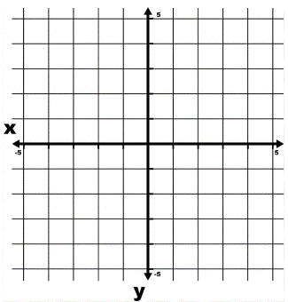

Three vertices of  are given. Find the coordinate of the remaining vertex.

3.  4. 

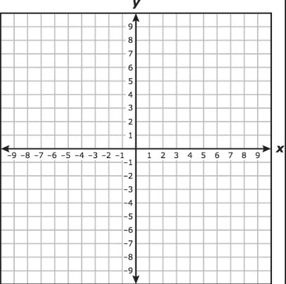

5.  6. 



Graph the quadrilateral with the given vertices in a coordinate plane. Then show that the quadrilateral is a parallelogram by using the assigned properties and theorems.

Slope:  Length:  Midpoint: 

7.  8. 

Definition of a parallelogram Converse of both pairs of opposite sides congruent

Slope of  _________ Length of  _________

Slope of  _________ Length of  _________

Slope of  _________ Length of  ________

Slope of  _________ Length of  ________

9.  10. 

Converse of one pair of opposite sides both Converse of diagonals bisect each other

Parallel and congruent Midpoint of  __________

Slope of  _________ Midpoint of  __________

Slope of  _________

Length of  _________

Length of  ________

Decide whether  is a rectangle, a rhombus, or a square. Justify your answers.

11.  12. 



Slope of  _________ Slope of  _________

Slope of  _________ Slope of  _________

Slope of  _________ Slope of  __________

Slope of  _________ Slope of  _________

Type of Parallelogram: __________________________ Type of Parallelogram: __________________________

Justification: __________________________________ Justification: __________________________________

_____________________________________________ _____________________________________________

13.  14. 



Slope of  _________ Slope of  _________

Slope of  _________ Slope of  _________

Slope of  _________ Slope of  __________

Slope of  _________ Slope of  _________

Type of Parallelogram: __________________________ Type of Parallelogram: __________________________

Justification: __________________________________ Justification: __________________________________

_____________________________________________ _____________________________________________