8th Grade Math

Unit 9 Notes

Data Analysis and Displays

Name _______________________

Period ________________________

Chapter 9 ALEKS is due on: _______________

There are _____ topics total, so I need to

complete _____ every school day!

**LESSON 9.1 BELLWORK**

**Graph the line. (Hint: Use y = mx+b m=slope b=y-intercept)**

1. 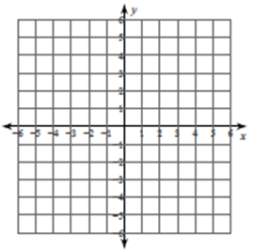 **2) $y=-x+2$**

 **3) $y=x+1$ 4) $y=3$ (Hint: Use “HOY VUX”)**

**Lesson 9.1 – Scatter Plots**

**Goal: I can make a scatter plot and describe the correlation.**

|  |  |  |
| --- | --- | --- |
| **Word** | **Definition** | **Picture or Example** |
| **Scatter plot** | A graph that shows the relationship between two data sets. The two sets of data are graphed as ordered pairs on a coordinate plane. |  |
| **Association of two data sets** |  | |

Do you think there is a relationship between the distance from GO and the cost of a property on a Monopoly board? Use the table below to create a scatter plot and see.

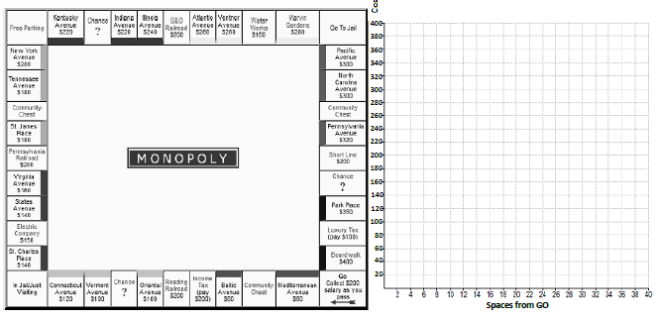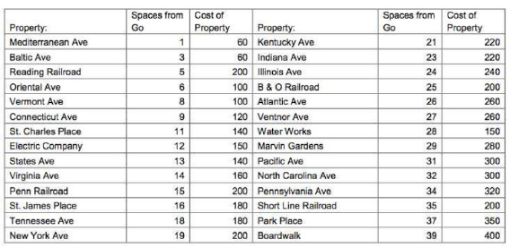

Describe the association between *x* and *y*. Circle any clusters and put a star next to any outliers.

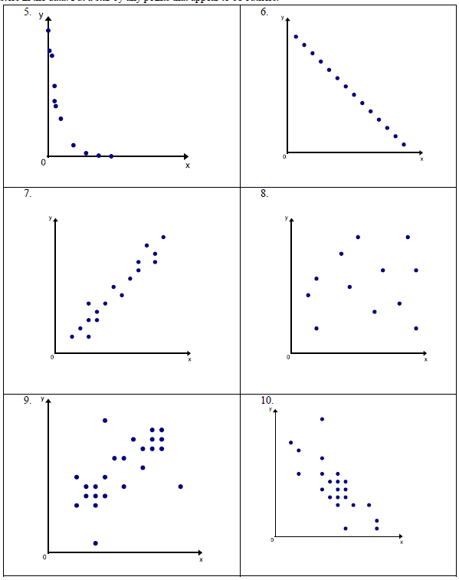

9)

8)

7)

6)

5)

4)

Describe the relationship you would expect between the data. Explain.

10. age of the automobile and the odometer reading

11. time spent fishing and the amount of bait in the bucket

12. number of passengers in a car and the number of traffic lights on the route

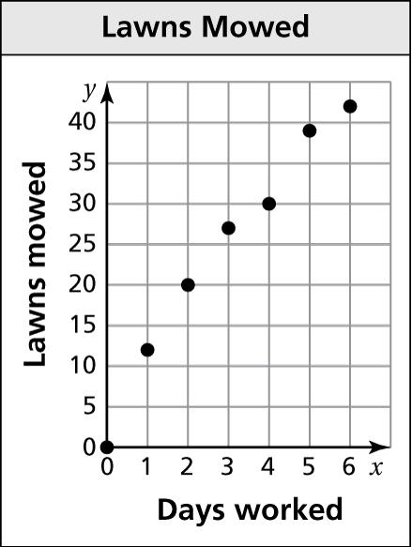

13. The scatter plot shows the number of lawns mowed by

a lawn care business during one week.

a. How many days does it take to mow 30 lawns?

b. About how many lawns can be mowed in 1 day?

c. Describe the relationship shown by the data.

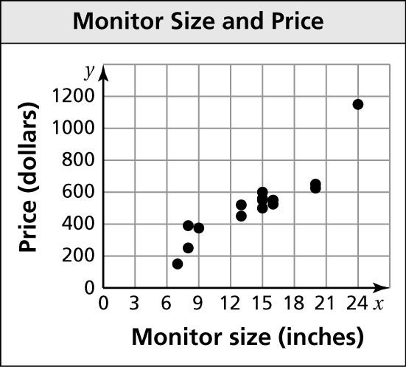Describe the relationship between the data. Identify any outliers, gaps, or clusters.

14. 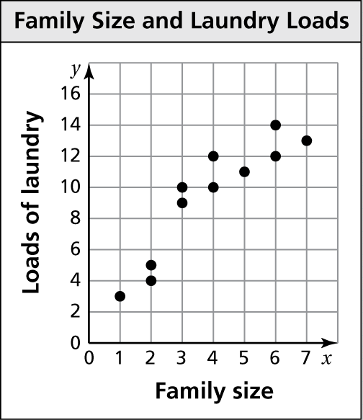 15.

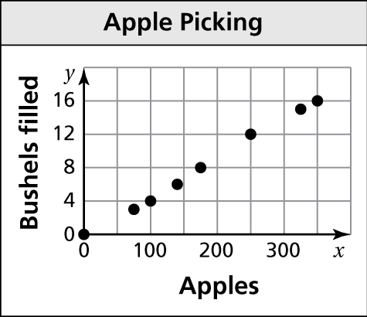16. The scatter plot shows the numbers of bushels filled   
and the numbers of apples picked.

a. How many bushels are needed for 350 apples?

b. About how many apples can be placed in 8 bushels?

c. Describe the relationship shown by the data.

17. The table shows the number of students remaining on an after-school bus and the number of minutes since leaving the school.

|  |  |  |  |  |  |  |  |
| --- | --- | --- | --- | --- | --- | --- | --- |
| Number of students | 56 | 45 | 39 | 24 | 17 | 6 | 0 |
| Minutes | 0 | 5 | 9 | 15 | 23 | 26 | 32 |

a. Plot the ordered pairs from the table in a coordinate plane.

b. Describe the relationship between the two data sets.

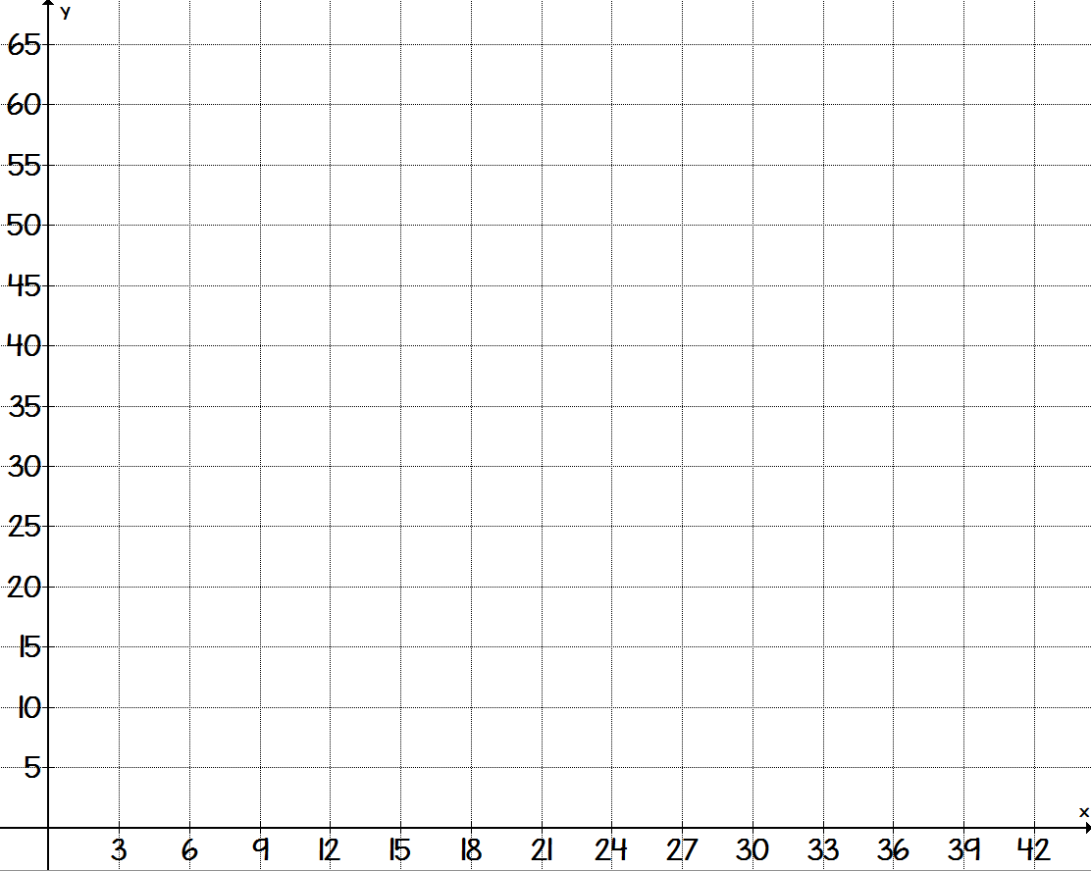



**LESSON 9.2 BELLWORK**

In Exercises 1–5, use the scatter plot.

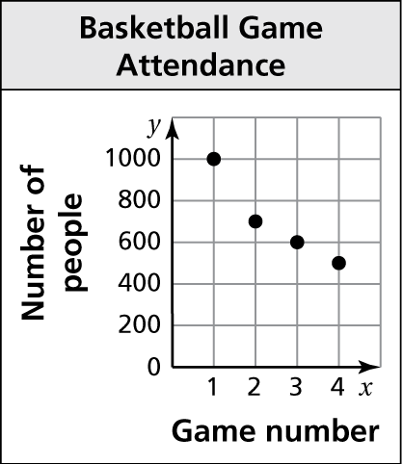

1. Which game did 500 people attend?

2. How many people attended Game 2?

3. Did more people attend Game 2 or Game 3?

4. How many more people attended Game 1 than Game 4?

5. Describe the relationship shown by the data.

Tell whether the data show a *positive*, a *negative*, or *no* relationship.

6. 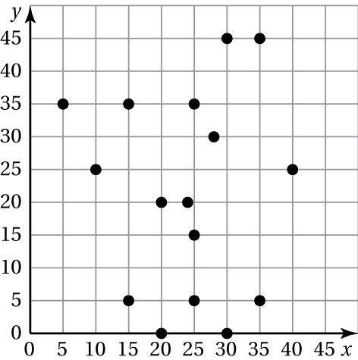 7. 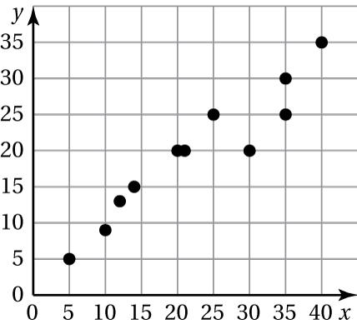 8. 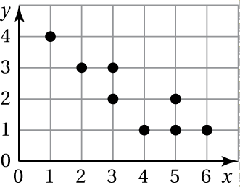

**Lesson 9.2 – Lines of Fit**

**Goal: I can find the line of best fit on a scatter plot and use it to make predictions.**

|  |  |  |
| --- | --- | --- |
| **Word** | **Definition** | **Picture or Example** |
| **Line of Fit** | a line drawn on a scatter plot close to most of the data points. This line can be used to estimate or make predictions when an equation is written in y = mx + b form. |  |

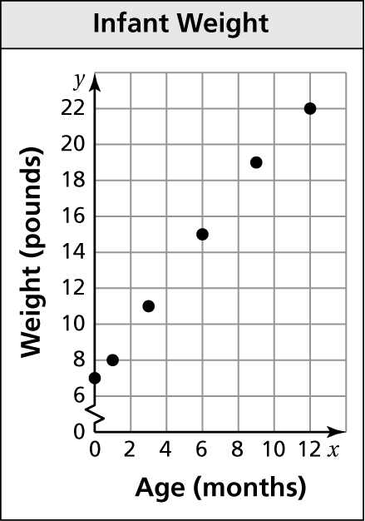1. The scatter plot shows the weights *y* of an infant   
from birth through *x* months.

a. At what age did the infant weigh 11 pounds?

b. What was the infant’s weight at birth?

c. Draw a line that you think best approximates   
the points.

d. Write an equation for your line.

e. Use the equation to predict the weight of the   
infant at 18 months.

f. Does the data show a *positive*, a *negative*, or *no* relationship?

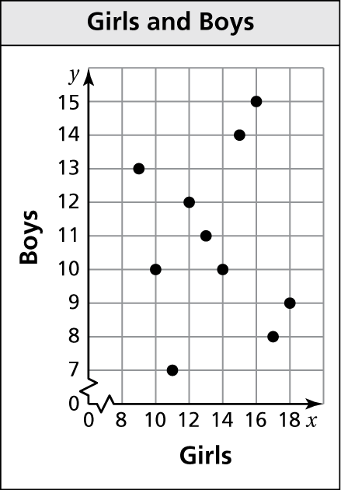2. The scatter plot shows the relationship between   
the numbers of girls and the numbers of boys in   
10 different classrooms.

a. What type of relationship, if any, does the   
data show?

b. Is it possible to find the line of fit for the   
data? Explain.

c. Is it reasonable to use this scatter plot to   
predict the number of boys in the classroom   
based on the number of girls? Explain.

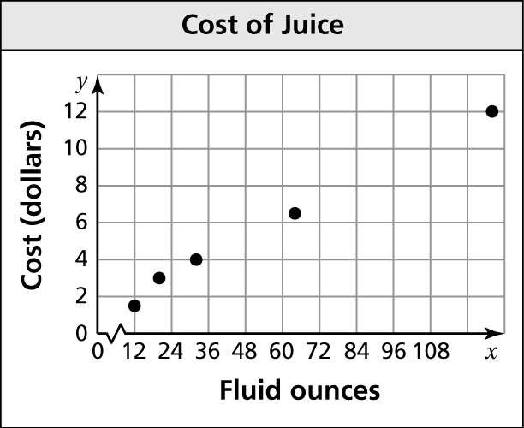3. The scatter plot shows the costs *y* of bottles containing *x* fluid ounces of juice.

a. How much does a 12 oz of juice cost?

b. How many fluid ounces of juice can you   
purchase for $12?

c. Draw a line that you think best approximates   
the points.

d. Write the equation for the line of best fit.

e. Use the equation to predict the cost of a 256-fluid ounce container of juice.

f. Does the data show a *positive*, a *negative*, or *no* relationship?

4. The table shows the numbers of losses *y*  
a gamer has *x* weeks after getting a new   
video game. (Use Desmos)

|  |  |  |  |  |  |  |  |
| --- | --- | --- | --- | --- | --- | --- | --- |
| Week, *x* | 1 | 2 | 3 | 4 | 5 | 6 | 7 |
| Losses, *y* | 15 | 12 | 10 | 7 | 6 | 3 | 1 |

a. Make a scatter plot of the data on desmos.

b. Use desmos to write an equation for the line best of fit.

c. Does the data show a relationship?

d. Interpret the relationship.

How to find the line of best fit on desmos.com

**The table shows how many million Beyoncé albums, *y*, remain in a store *x* days after being released.**

|  |  |  |  |  |  |  |  |  |
| --- | --- | --- | --- | --- | --- | --- | --- | --- |
| Days, *x* | 1 | 2 | 3 | 4 | 5 | 6 | 7 | 8 |
| Albums (in millions), y | 18 | 17 | 15 | 13 | 12 | 9 | 6 | 4 |

1. Write an equation for the line of best fit.
2. Use your equation to predict how many albums will be in that store 11 days after being released.

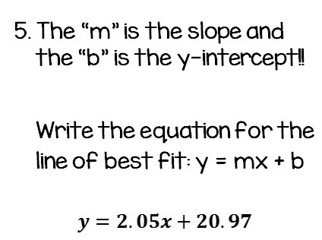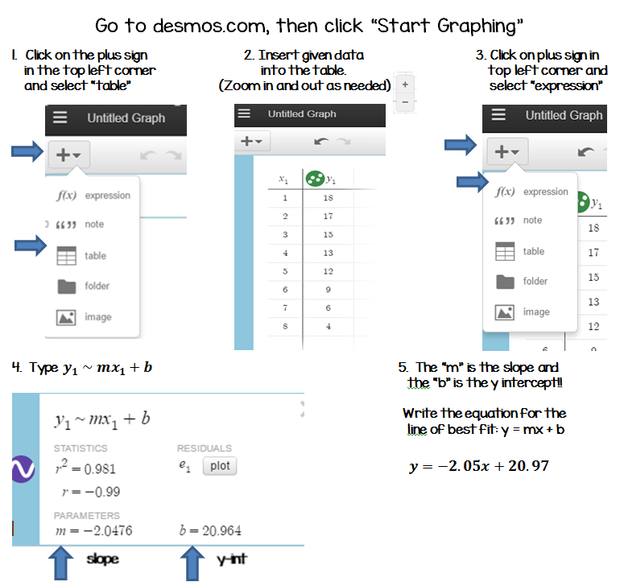

**LESSON 9.3 BELLWORK**

1. The table shows the money you owe to pay off a credit card bill over five months.

a. Make a scatter plot of the data and draw a line of fit.

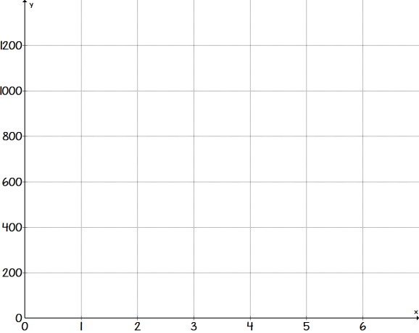

|  |  |
| --- | --- |
| Months, *x* | Money owed (dollars), *y* |
| 1 | 1200 |
| 2 | 1000 |
| 3 | 850 |
| 4 | 600 |
| 5 | 410 |





b. Write an approximate equation of the line of fit.

c. Interpret the slope and *y*-intercept of the line of fit.

d. Predict the amount of money you will owe in six months.

**Lesson 9.3 – Two-Way Tables**

**Goal: I can construct and analyze a two-way table.**

|  |  |  |
| --- | --- | --- |
| **Word** | **Definition** | **Picture or Example** |
| **Two-Way Table** | Displays two categories of data collected from the same source. | Image result for two way table example |
| **Joint frequency** | Each entry in a two way table |
| **Marginal frequencies** | The sums of the rows and columns in a two-way table. |

|  |  |  |  |
| --- | --- | --- | --- |
|  |  | Bread | |
|  |  | White | Wheat |
| Meat | Ham | 54 | 25 |
| Turkey | 37 | 84 |

1. Find and interpret the marginal frequencies.

2. You randomly survey students in your school. You ask whether they spend   
more leisure time watching television, playing video games, or going online.   
You display your results in the two-way table.

|  |  |  |  |  |
| --- | --- | --- | --- | --- |
|  |  | Leisure Time | | |
|  |  | Television | Video games | Internet |
| Grade | 10th | 25 | 38 | 12 |
| 11th | 32 | 26 | 16 |
| 12th | 30 | 20 | 30 |

a. How many 11th-graders chose   
playing video games?

b. Find and interpret the marginal   
frequencies for the survey.

1. What percent of students in the   
   survey are the 12th-graders who   
   spend more time going online?

3. You randomly survey your classmates about the color of their hair. The results   
are shown in the tables.

|  |  |  |  |
| --- | --- | --- | --- |
| Hair Color of Female Classmates | | | |
| Red | Blonde | Brunette | Black |
| 3 | 15 | 41 | 33 |

a. Make a two-way table.

|  |  |  |  |  |  |  |
| --- | --- | --- | --- | --- | --- | --- |
|  |  | Hair Color | | | | |
|  |  |  |  |  |  | **Total** |
| Gender |  |  |  |  |  |  |
|  |  |  |  |  |  |
| **Total** |  |  |  |  |  |

|  |  |  |  |
| --- | --- | --- | --- |
| Hair Color of Male Classmates | | | |
| Red | Blonde | Brunette | Black |
| 4 | 21 | 30 | 27 |

|  |  |  |  |  |  |  |
| --- | --- | --- | --- | --- | --- | --- |
|  |  | Hair Color | | | | |
|  |  |  |  |  |  | **Total** |
| Gender |  |  |  |  |  |  |
|  |  |  |  |  |  |
| **Total** |  |  |  |  |  |

b. Find and interpret the marginal   
frequencies for the survey.

c. For each hair color, what percent   
of the students in the survey are   
female? male? Organize the   
results in a two-way table.

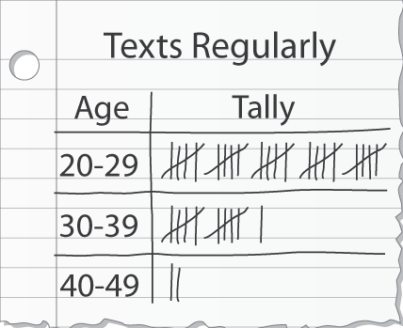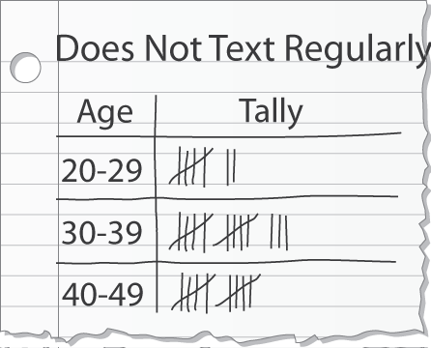4. You randomly survey people in the mall about whether or not they regularly use text messaging. The results are shown in the tally sheets.

|  |  |  |  |  |
| --- | --- | --- | --- | --- |
|  |  | Age Range | | |
|  |  |  |  | **Total** |
| Texts  Regularly? |  |  |  |  |
|  |  |  |  |
| **Total** |  |  |  |

a. Make a two-way table that includes the marginal frequencies.

b. For each age group, what percent of the people in the survey text regularly? do not text regularly? Organize the results in a two-way table. Explain what one of the entries represents.

|  |  |  |  |  |
| --- | --- | --- | --- | --- |
|  |  | Age Range | | |
|  |  |  |  | **Total** |
| Texts  Regularly? |  |  |  |  |
|  |  |  |  |
| **Total** |  |  |  |

c. Does the table in part (b) show a relationship between age and texting?

**LESSON 9.4 BELLWORK**

1. You randomly survey students in a school about whether they got the flu after receiving a flu shot. The results of the survey are shown in the two-way table.

|  |  |  |  |  |
| --- | --- | --- | --- | --- |
|  |  | Flu Shot | |  |
|  |  | Yes | No | Total |
| Flu | Yes | 8 | 13 |  |
| No | 27 | 32 |  |
|  | Total |  |  |  |

a. How many of the students   
in the survey received a   
flu shot and still got the flu?

b. Find and interpret the marginal frequencies for the survey.

2. You randomly survey students in a school about whether they eat breakfast at home or at school.

**Grade 6 Students:** 28 eat breakfast at home, 12 eat breakfast at school

**Grade 7 Students:** 15 eat breakfast at home, 15 eat breakfast at school

**Grade 8 Students:** 9 eat breakfast at home, 21 eat breakfast at school

1. Make a two-way table that includes the marginal frequencies.

|  |  |  |  |  |  |
| --- | --- | --- | --- | --- | --- |
|  |  | Grade | | |  |
|  |  |  |  |  | Total |
| Breakfast |  |  |  |  |  |
|  |  |  |  |  |
|  | Total |  |  |  |  |

b. For each grade level, what percent of the students in the survey eat:

breakfast at home?

eat breakfast at school?

**Lesson 9.4 – Choosing a Data Display**

**Goal: I can choose and construct an appropriate data display.**

|  |  |  |
| --- | --- | --- |
| **Word** | **Definition** | **Picture or Example** |
| **Pictograph** | shows data using pictures |  |
| **Bar Graph** | shows data in specific categories |  |
| **Circle Graph** | shows data as part of a whole |  |
| **Line Graph** | shows how data changes over time |  |
| **Histogram** | shows frequencies of data values in intervals of the same size |  |
| **Stem-and-Leaf Plot** | orders numerical data and shows how they are distributed |  |
| **Box-and-Whisker Plot** | shows the variability of a data set by using quartiles |  |
| **Dot Plot** | shows the number of times each value occurs in a data set |  |
| **Scatter Plot** | shows the relationship between two sets of data on a coordinate plane |  |
| **Misleading Graph** | a graph that is not drawn appropriately | *No title  *Numbers not evenly spaced  *Scale does not start at zero  *No key (if needed)  *Axes not labeled  *Parts are different sizes |

Choose an appropriate data display for the situation. Explain your reasoning.

1. the heights of girls in grades 6 through 12

2. the numbers of computers offered within $100 price ranges

3. the comparison of the number of students and the number of office staff

4. the percentages of income budgeted for food, utilities, housing, gas, and education

Explain why the data set is misleading.

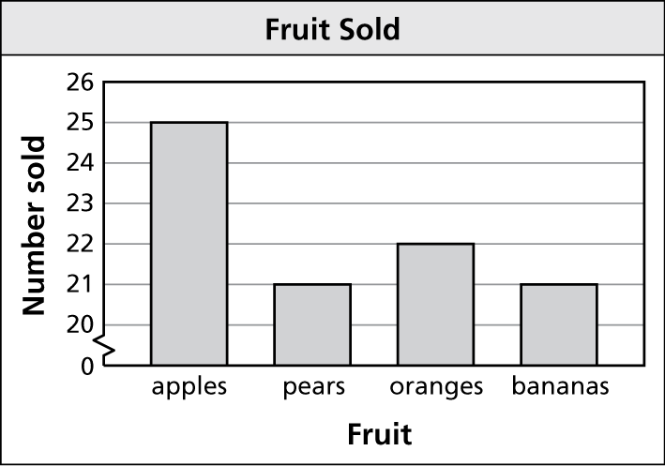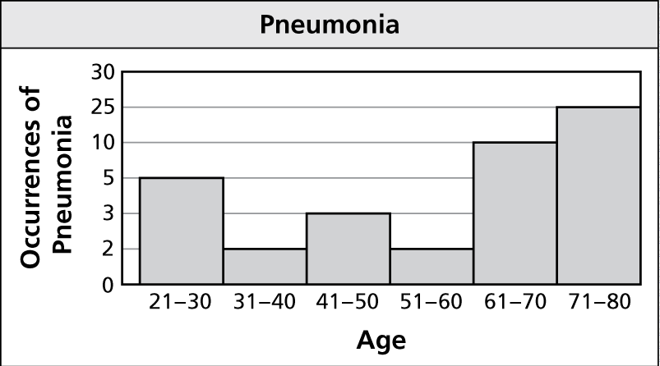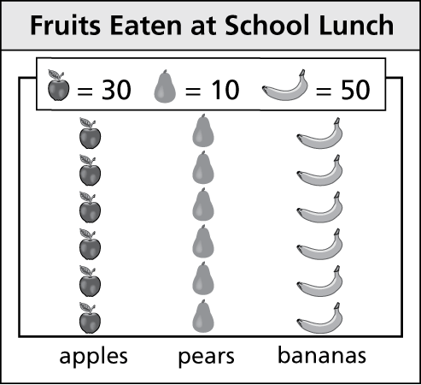 5. 6. 7.

8. You spin a spinner 20 times and want to use a data display to show   
the number of times each of the numbers 1 through 5 occurs. Choose   
an appropriate data display for the situation. Explain your reasoning.

9. What type of data display is appropriate for showing the median of the   
data values?

10. A professor wants to use a data display to show the relationship between class sizes and passing rates for college students. Choose an appropriate data display for the situation. Explain your reasoning.

11. A dentist wants to use a data display to show the percentages of clients using different types of toothbrushes. Choose an appropriate data display for the situation. Explain your reasoning.

12. The new executive was making a presentation to the Board of Directors.   
He used a pictograph to show the weekly profits made by his department during the last 3 months.

a. Explain why this would be an inappropriate use of a data display.

b. Choose an appropriate data display for his situation.

**Unit 9**

**Data Analysis and Displays**

|  |
| --- |
| **I can:**  **I can make a scatter plot and describe the correlation.**  **I can find the line of best fit on a scatter plot and use it to make predictions.**    **I can construct and analyze a two-way table.**  **I can choose and construct an appropriate data display.** |
| **Vocabulary:**    **Scatter plot**  **Correlation**  **Line of fit**  **Line of best fit**  **Two-way table**  **Joint frequency**  **Marginal frequency** |
| **Assignments:**  **Lesson 9.1 - Scatter Plots - Page 376 #1-15**  **Lesson 9.2 - Lines of Fit - Page 382 #1-9**  **Lesson 9.3 - Two-Way Tables - Page 390 #3-12**  **Lesson 9.4 – Choosing a Data Display – Page 397 #1-18** |