**Name _____________________________ Hour _________**

**Standard 6A Proofs about Lines & Angles and Standard 6B Proofs about Parallel Lines & Transversals Review**

**A.** Complementary Angles

**B.**  Congruent

**C.** Midpoint

**D.** Supplementary Angles

**E.** Angle Bisector

**F.** Linear Pair

**G.** Segment Addition Postulate

**H.** Transitive Property

**I.** Symmetric Property

**J.** Reflexive Property

**K.** Same Side Interior Angles

**L.** Vertical Angles

**M.** Angle Addition Postulate

**N.** Alternate Interior Angles

**O.** Alternate Exterior Angles

**P.** Corresponding Angles

**1-14. Fill in the blank with the correct vocab word.**

**1.** A point that divides a segment into to two congruent pieces:_______

**2.** Two angles that are adjacent and supplementary: _______

**3.**  If a = b and b = c, then a = c _______

**4.**  A ray that divides an angle into two congruent angles: _______

**5.** The larger segment is equal to the sum of the segments that comprise it. _______

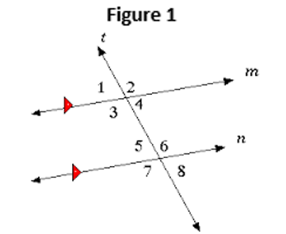**6.** A pair of angles that sum to 90 degrees: _______

**7.** Using **Figure 1**, ≅ because they are _______

**8.** Using **Figure 1**,  because they are _______

**9.** Using **Figure 1**, ≅ because they are _______

**10.** Using **Figure 1**, ≅ because they are _______

**11.** Using **Figure 1**,  because they are _______

**12.** Using **Figure 1**,  because they are _______

**13.** If a transversal intersects two parallel lines, the same side interior angles are ____

**14.** Vertical angles are _______

**15. Solve for x 16. Given K is a midpoint Solve for x**

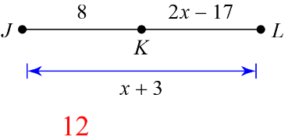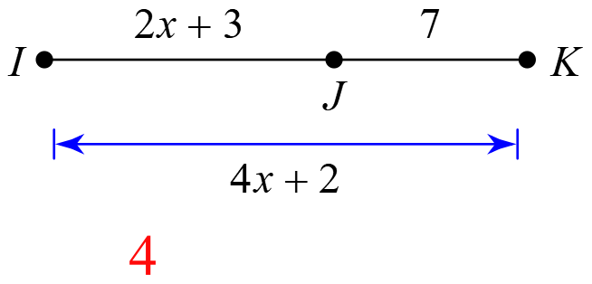

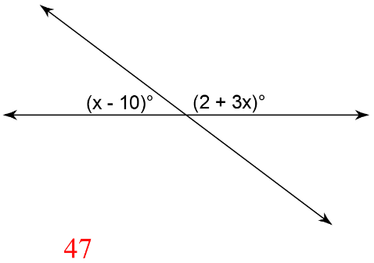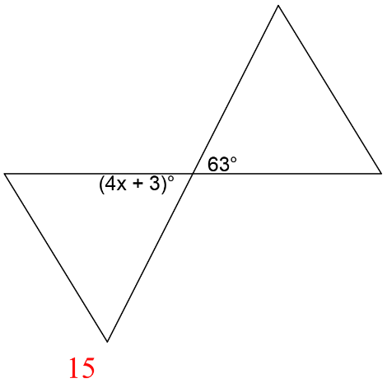**17. Solve for x**  **18. Solve for x**

**19-27. Prove the following using the given statements and reasons.**

**Given:** JK = 5x + 1

12

x + 5

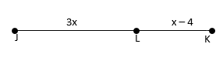**Prove:** x = 4

|  |  |
| --- | --- |
| **Statements** | **Reasons** |
| **19.** | Given |
| **20.** | Segment Addition Postulate |
| 12 + x + 5 = 5x +1 | **21.** |
| **22.** | Substitution Property |
| $$17=4x+1$$ | **23.** |
| **24.** | Subtraction Property of Equality |
| **25.** | **26.** |
| x = 4 | **27.** |

**Possible Statements: Possible Reasons:**

$16=4x$ Substitution Property

$17+x=5x+1$ Segment Addition Postulate

 Symmetric Property of Equality

 Subtraction Property of Equality

$7+x=5x+1$ Division Property of Equality

$JK=5x+1$ Addition Property of Equality

Given

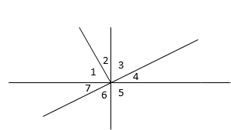

**28-31.** **Prove the following using the given statements and reasons**

Given: $∠2≅28°$ and $∠2≅∠4$

Prove: $∠7≅28°$

|  |  |
| --- | --- |
| **Statements** | **Reasons** |
| **28.** | Given |
| $$∠7≅∠4$$ | **29.** |
| **30.** | Transitive Property of Congruence |
| $$∠7≅28°$$ | **31.** |

**Possible Statements: Possible Reasons:**

$∠7≅∠2$ Angle Addition Postulate

$∠3≅∠6$ Definition of a linear pair

$∠2≅28°$ and $∠2≅4$ Substitution Property

$∠7+∠6+∠5≅180°$ Vertical Angles are Congruent

$∠4≅∠7$ Transitive Property of Congruence

**What value of x makes u || v?**

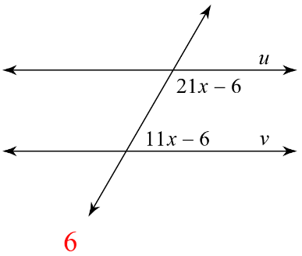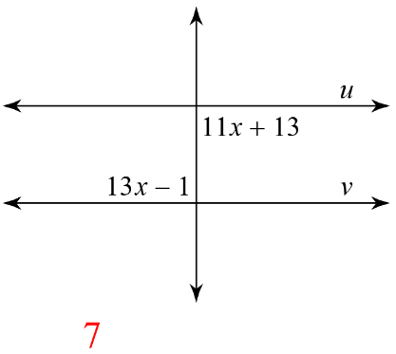**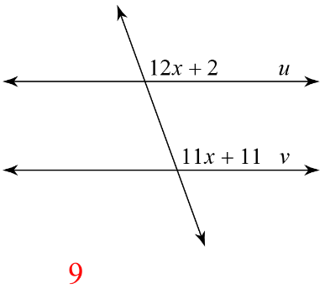32. 33. 34.**

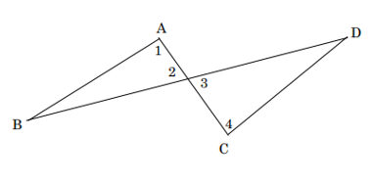

**Complete the proof below for 22-27.**

Given: 



Prove: 

|  |  |
| --- | --- |
| Statement | Reason |
| **35.** | Given |
|  | **36.** |
| **37.** | Transitive Property |
|  | **38.** |
| **39.** | Transitive Property |
|  | **40.** |

**Possible Statements: Possible Reasons:**

|  |  |
| --- | --- |
|  | * Converse of Corresponding Angles Theorem * Given * Definition of a Linear Pair * Vertical Angles are Congruent * Transitive Property * Converse of Alternate Interior Angles Theorem |

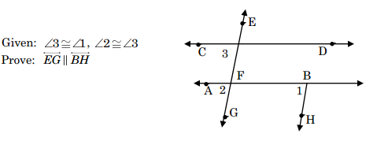**41-51. Fill in the blanks with the correct responses from the list of possibilities.**

|  |  |
| --- | --- |
| Statement | Reason |
|  | **41.** |
|  | **42.** |
| are Corresponding Angles | **43.** |
|  | **44.** |

**Possible Reasons:**

* + Vertical angles are congruent
  + Substitution property of equality
  + Given
  + Transitive Property of Congruence
  + If ll lines, Alternate Interior Angles are congruent
  + Definition of Corresponding Angles
  + 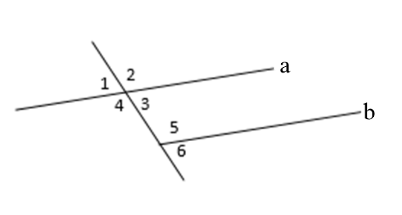If Corresponding Angles are congruent then the lines are parallel

Given: , , 

Prove: 

|  |  |
| --- | --- |
| Statement | Reason |
| ,  , | **45.** |
|  | **46.** |
| **47**. | Substitution property of equality |
|  | **48.** |
| **49** | Subtraction property of equality |
| **50.** | Division property of equality |
| **51.** | Symmetric property of equality |

**Statements: Reasons:**

 Vertical angles are congruent

 Substitution property of equality

 Given

 Addition property of equality

 If ll lines, Same Side Interior Angles are Supplementary

Subtraction property of equality