Proofs Review Name:______________________________ Hr: ______
1.

2.

3.

4.

5. Write a two-column proof

Statement | Reason
1. n||p | 1.
2. | 2.
3. m∠1 = m∠3 | 3.
4. ∠2 and ∠3 are supplementary | 4. Linear Pairs Postulate
5. | 5. Definition of supplementary angles
6.  7. | 6. Substitution Property of Equality  7.

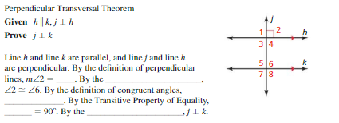
6.

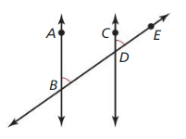
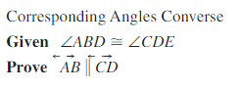
7. Fill in the blanks then write a two-column proof

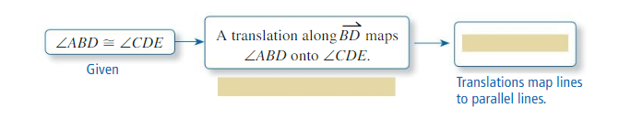

Statement | Reason
1. | 1.
2. | 2.
3. | 3.

8. Fill in the blanks then write a two-column proof

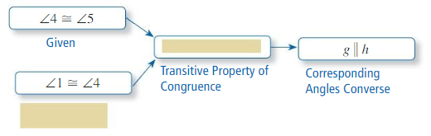

Statement | Reason
1. | 1.
2. | 2.
3.  4. | 3.  4.

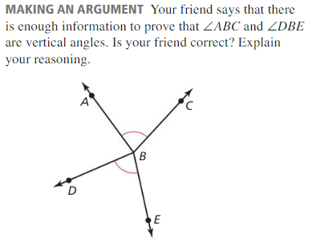
9.

For 10 -12
10.

11.

12.

