9th Grade Math

Chapter 9 Notes

Arithmetic and Geometric Sequences

Name \_\_\_\_\_\_\_\_\_\_\_\_\_\_\_\_\_\_\_\_\_\_\_

Period \_\_\_\_\_\_\_\_\_\_\_\_\_\_\_\_\_\_\_\_\_\_\_\_

Chapter 9 ALEKS is due on: \_\_\_\_\_\_\_\_\_\_\_\_\_\_\_

There are \_\_\_\_ topics total, so I need to

do \_\_\_\_\_ topics every school day!

**LESSON 9.1 BELLWORK**

**\*Growing Dots\***

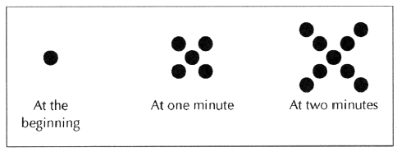

1. Describe the pattern you see in the sequence of figures above.

2. Assuming the same pattern continues, how many dots will there be at 3 minutes?

3. How many dots will there be at 100 minutes?

4. Use what you have found to make a table, write an equation and graph the sequence.

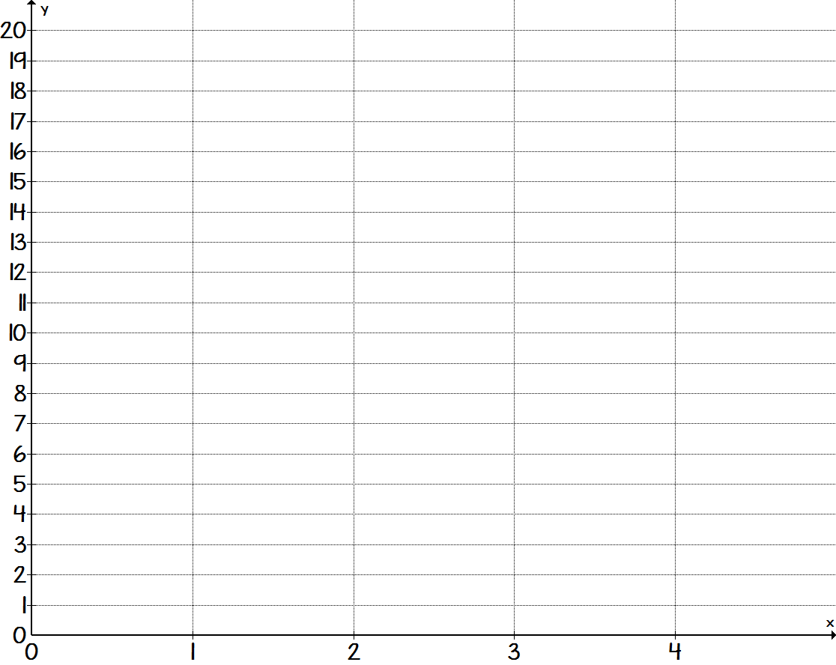

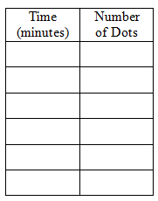

Equation:

**Lesson 9.1 –Arithmetic Sequences**

**Goal: I can recognize and write explicit and recursive formulas for arithmetic sequences.**

|  |  |  |
| --- | --- | --- |
| **Word** | **Definition** | **Picture or Example** |
| **Sequence** | A set of numbers, called terms, arranged in a particular order. | 7, 12, 17, 22, …  1st term = 7  2nd term = 12  3rd term = 17  4th term = 22 |
| **Arithmetic Sequence** | A sequence that has an **addition** pattern.  The difference between each term in the sequence is the same.  The graph will be **linear**.  **7, 12, 17, 22** | TA: C:\cur_proj\Word Files\Arts\PNGs\HSAlg1_t_0406_011.pngArithmetic Sequence: |
| **Common Difference** | The number being added to each term in a sequence. |
| **Arithmetic**  **Explicit**  **Formula** | The equation that can be used to find any term in a sequence.  The equation is in slope-intercept form once it is simplified. The slope is the common difference and the y-intercept is *a* 0. |  |
| **Arithmetic Recursive**  **Formula** | The recursive rule gives the first number in a sequence, and the common difference.  The recursive rule will not find any number in a sequence, unless you know the term before the one you are looking for. |  |

Write the next three terms in the arithmetic sequence.

1. 1, 8, 15, 22, … 2. 20, 14, 8, 2, … 3. 12, 21, 30, 39, …

4. 5, 3, 1, -1, … 5. First term: -2 6. First term: 36

Common Difference:8 Common Difference: -5

Find the common difference of the arithmetic sequence.

7. 42, 36, 30, 24, … 8. 15, 26, 37, 48, … 9. 15, 4, -7, -18, …

Make a table and then graph the arithmetic sequence.

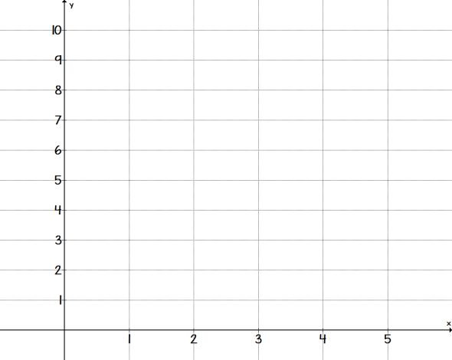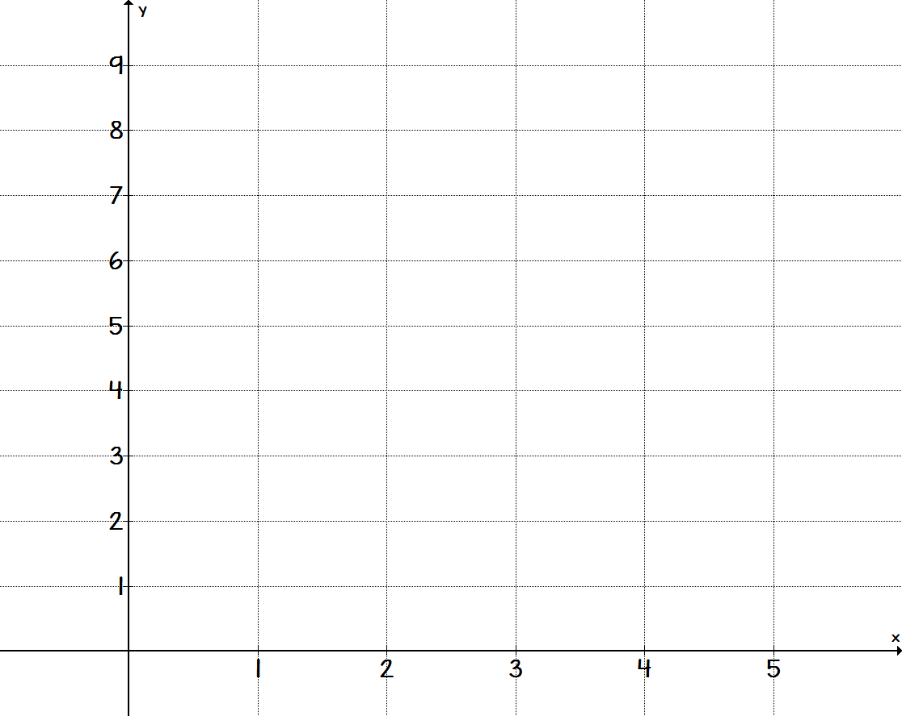 10. 1, 3, 5, 7, ... 11. 

|  |  |
| --- | --- |
| **Position, n** | **Term,** |
|  |  |

|  |  |
| --- | --- |
| **Position, n** | **Term,** |
|  |  |

 12. 16, 12, 8, 4, ... 13. 2, 3.5, 5, 6.5, ...

|  |  |
| --- | --- |
| **Position, n** | **Term,** |
|  |  |

|  |  |
| --- | --- |
| **Position, n** | **Term, $a_{n}$** |
|  |  |

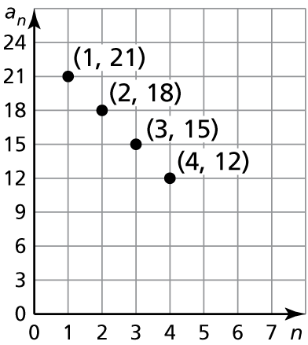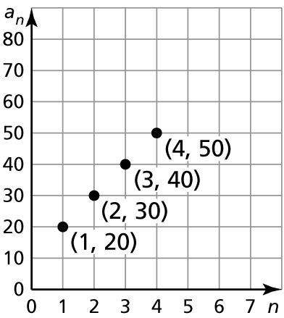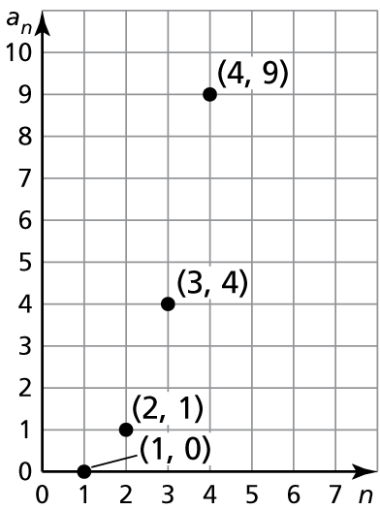Determine whether the graph represents an arithmetic sequence. Explain.

14. 15. 16.

|  |  |  |  |  |  |
| --- | --- | --- | --- | --- | --- |
|  | **Pattern** | **Common Difference** | **Explicit Formula** | $$a_{10}$$ | **Recursive Formula** |
| **17.** | 9, 17, 25, 33, ... |  |  |  |  |
| **18.** | 31, 24, 17, 10, ... |  |  |  |  |
| **19.** |  |  |  |  | $a_{1}=17$ $$a_{n}=a_{n-1}+2$$ |
| **20.** |  |  |  |  |  |
| **21.** |  |  |  |  |  |
| **22.** |  |  |  |  |  |

23. In an auditorium, the first row of seats has 30 seats. Each row behind the first row has 4 more seats than the row in front of it. How many seats are in the 25th row?

**Arithmetic Sequences Day 2 Bellwork**

**Fill in the table.**

|  |  |  |  |  |  |
| --- | --- | --- | --- | --- | --- |
|  | **Sequence** | **Common Difference** | **Explicit Formula** | $$a_{12}$$ | **Recursive Formula** |
| **1.** | 12, 6, 0, -6, ... |  |  |  |  |
| **2.** | 22, 24, 26, 28, ... |  |  |  |  |
| **3.** |  |  | $$a_{n}=-4n+17$$ |  |  |
| **4.** |  |  | $$a_{n}=5n+1$$ |  |  |
| **5.** |  |  |  |  | $a_{1}=-8$ $$a_{n}=a_{n-1}+9$$ |
| **6.** |  |  |  |  | $a_{1}=40$ $$a_{n}=a_{n-1}-3$$ |

**LESSON 9.2 BELLWORK**

**\*More Growing Dots\***

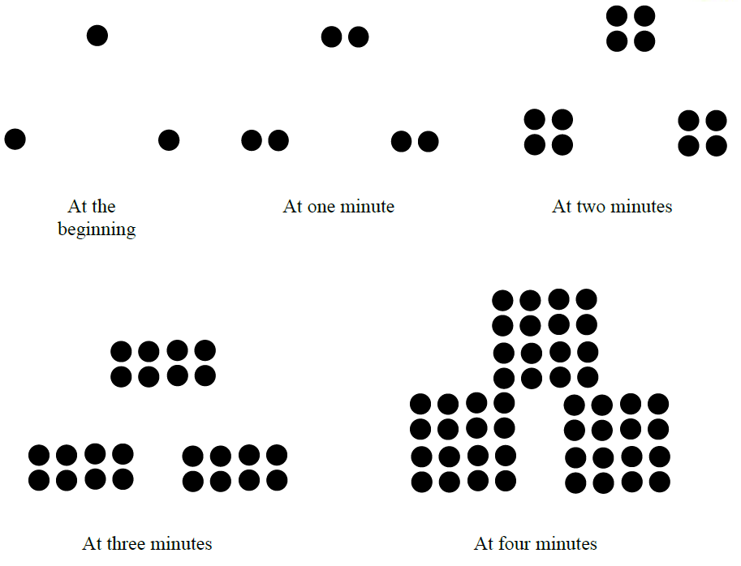

1. Describe the pattern you see in the sequence of figures above. Is it arithmetic?

2. Assuming the same pattern continues, how many dots will there be at 5 minutes?



3. Fill in the table and write an equation for the sequence.

(Hint: it’s not linear, it’s exponential.)

4. Use your equation to predict how many dots there will be after 10 minutes.

**Lesson 9.2 –Geometric Sequences**

**Goal: I can recognize and write explicit and recursive formulas for geometric sequences.**

|  |  |  |
| --- | --- | --- |
| **Word** | **Definition** | **Picture or Example** |
| **Geometric Sequence** | A sequence that has a **multiplication** pattern.  The common ratio between each term in the sequence is the same.  The graph will be **exponential**. | Geometric Sequence: |
| **Common Ratio** | The number being multiplied to each term in a sequence. |
| **Geometric**  **Explicit**  **Formula** | The equation that can be used to find any term in a sequence.  This equation will be in the form of an exponential function. | $$a_{n}=1{(5)}^{n-1}$$ |
| **Geometric Recursive**  **Formula** | The recursive rule gives the first number in a sequence, and the common ratio.  The recursive rule will not find any term in a sequence, unless you know the term before the one you are looking for. |  |

Determine whether the sequence is *arithmetic*, *geometric*, or *neither*. Explain your reasoning.

1.  2.  3. 

4.  5.  6. 

Write the next three terms of the geometric sequence.

7.  8.  9. 

Write an equation for the *n*th term of the geometric sequence. Then find *a*6.

10.  11.  12. 

13. 14.

|  |  |  |  |  |
| --- | --- | --- | --- | --- |
| ***n*** | 1 | 2 | 3 | 4 |
| ***an*** | 11 | 44 | 176 | 704 |

|  |  |  |  |  |
| --- | --- | --- | --- | --- |
| ***n*** | 1 | 2 | 3 | 4 |
| ***an*** | 2916 | 972 | 324 | 108 |

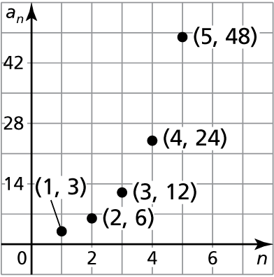

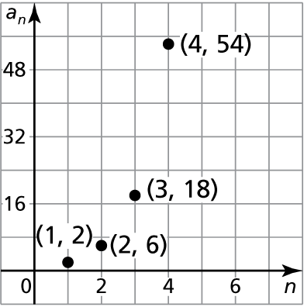 15. 16.

Make a table, write the explicit and recursive rule, and then graph the geometric sequence.

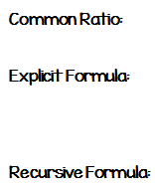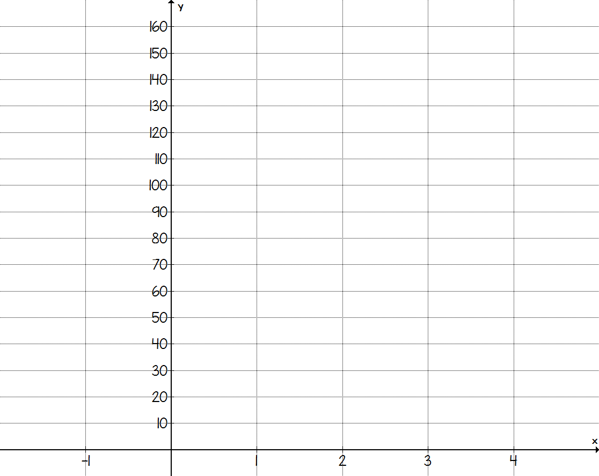 17. 6, 18, 54, 162, ...

|  |  |
| --- | --- |
| **Position, n** | **Term, $a_{n}$** |
|  |  |

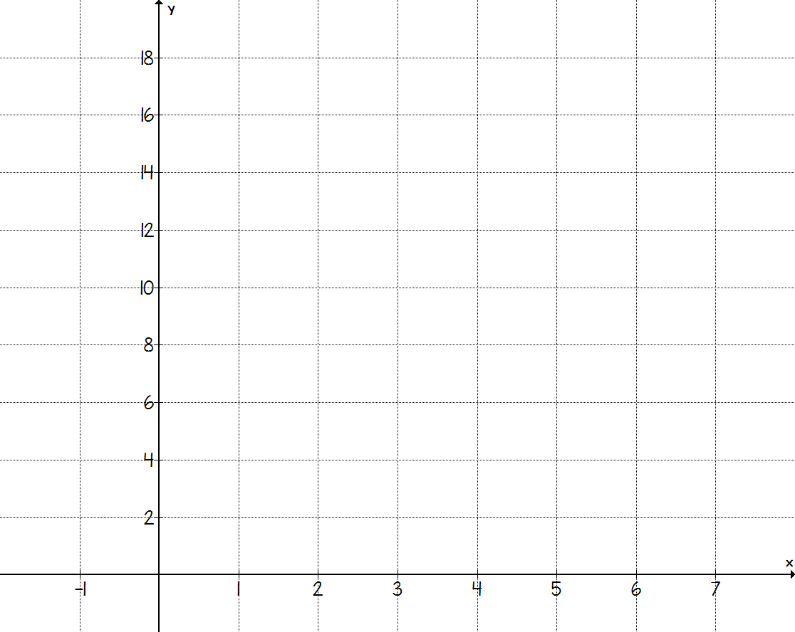18. 4, 2, 1, 0.5, ...

|  |  |
| --- | --- |
| **Position, n** | **Term,** |
|  |  |



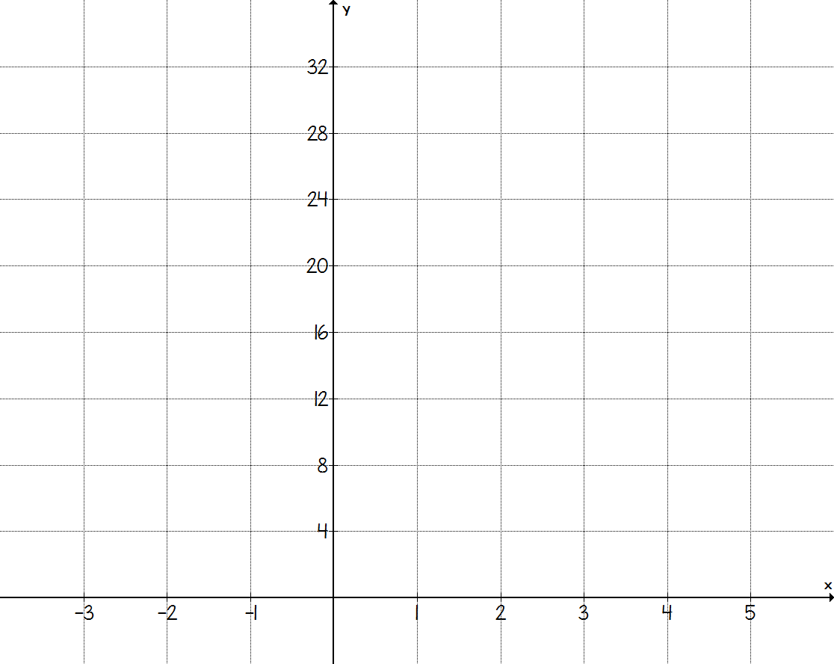**19.** 2, 4, 8, 16, ...



|  |  |
| --- | --- |
| **Position, n** | **Term, $a_{n}$** |
|  |  |

**Fill in the table.**

|  |  |  |  |  |  |
| --- | --- | --- | --- | --- | --- |
|  | **Sequence** | **Common Ratio** | **Explicit Formula** | $$a_{7}$$ | **Recursive Formula** |
| **20.** | 10, 20, 40, 80, ... |  |  |  |  |
| **21.** | 108, 36, 12, 4, ... |  |  |  |  |
| **22.** |  |  | $$a_{n}=-64{\left(\frac{1}{2}\right)}^{n-1}$$ |  |  |
| **23.** |  |  | $$a_{n}=4{\left(3\right)}^{n-1}$$ |  |  |
| **24.** |  |  |  |  | $a_{1}=6$ $$a_{n}=2∙a_{n-1}$$ |
| **25.** |  |  |  |  | $$a_{1}=\frac{1}{4}$$ $$a_{n}={8∙a}_{n-1}$$ |

**Geometric Sequences Day 2 Bellwork**

**Write the explicit and recursive equation for each graph.**

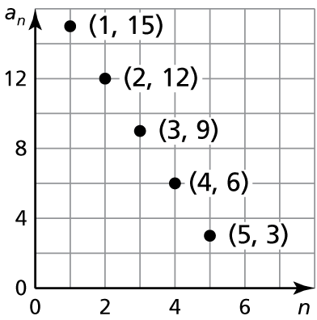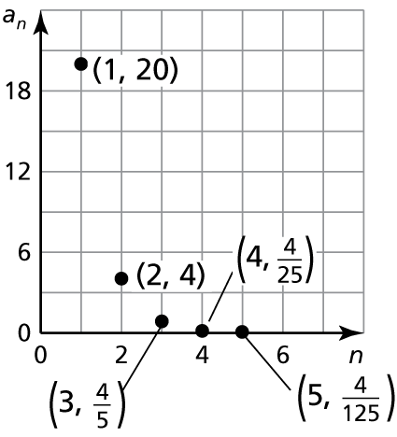

1. **2.**

Write an explicit rule for the recursive rule. Then find *a* 9.

3.  4.  5. 

Write a recursive rule for the explicit equation.

6.  7.  8. 

**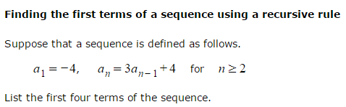**

**9.**

**Unit 9**

**Arithmetic and Geometric Sequences**

|  |
| --- |
| **I can:**  I can recognize arithmetic and geometric sequences.  I can write the explicit equation for arithmetic and geometric sequences.  I can write the recursive rule for arithmetic and geometric sequences.  I can graph arithmetic and geometric sequences.  I can find any term in a sequence. |
| **Vocabulary:**  Arithmetic Sequence Geometric Sequence  Linear Exponential  Common Difference Common Ratio  Explicit Equation Recursive Equation |
| **Assignments:**  Lesson 9.1 – Arithmetic Sequences – Lesson 9.1 Practice Worksheet  Lesson 9.2 – Geometric Sequences – Lesson 9.2 Practice Worksheet |