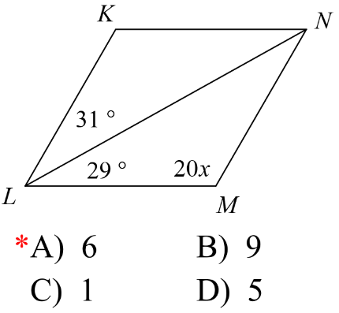_____1. Given the following parallelogram, solve for *x*.

(a) 1.6 (b) 3 (c) 6 (d) 7.6

_____2. Find a value for x that would prove the segment addition postulate.

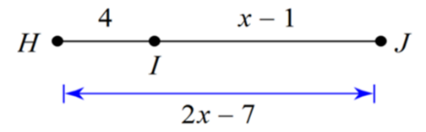 (a) 10 (b) 5 (c) 10/3 (d) 6

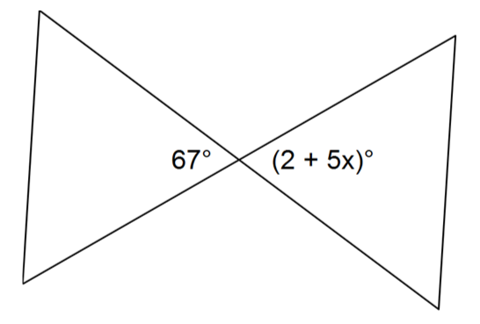

_____3. Solve for x.

(a) 60 (b) 13.8 (c) 22.2 (d) 13

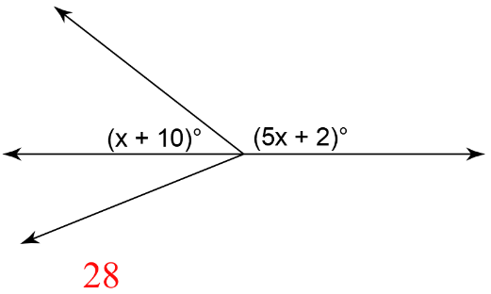

_____4. Solve for x

(a) $\frac{8}{5}$ (b) 28 (c) $\frac{4}{3}$ (d) 32

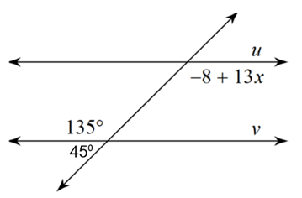

_____5. State the value for *x* that proves lines *u* and *v* are parallel.

(a) 9.77 (b) 4.08 (c) 11 (d) 130

_____6. Given the following rhombus, find the measure of $m∠DCE,$ and $m∠AEC$ given the $m∠ACE is 32° .$

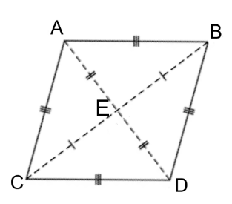(a) $m∠DCE=64°,$ $m∠AEC=90°$ (b) $m∠DCE=32°,$ $m∠AEC=64°$ (c) $m∠DCE=90°,$ $m∠AEC=32°$ (d) $m∠DCE=32°,$ $m∠AEC=90°$

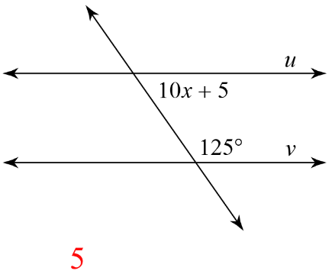

_____7. State the value for *x* that proves lines *u* and *v* are parallel.

(a) 5 (b) 13 (c) 12 (d) 6

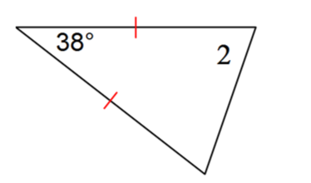_____8. Find the value of *x* if $m∠2=18x-1$

1. 2.17 (b) 7.89 (c) 4 (d) 71

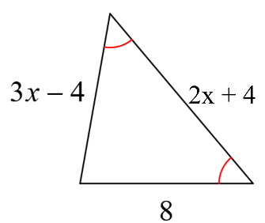_____9. Solve for *x*.

(a) $\frac{4}{3}$ (b) 2 (c) 8 (d) 4

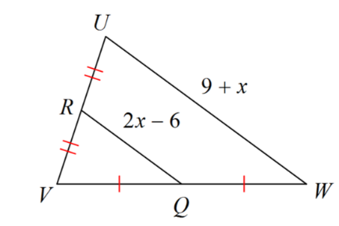

_____10. Solve for *x*.

(a) 1 (b) 7 (c) 5 (d) 15

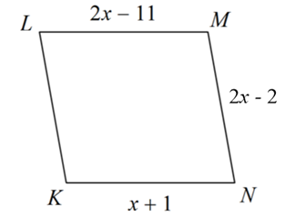



_____11. Given the following parallelogram, solve for *x*.

(a) 12 (b) 3 (c) 9/4 (d) 98

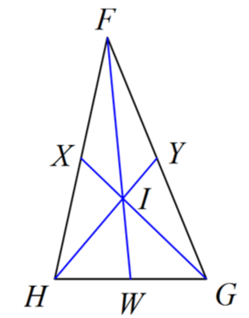

_____12. Given the segments are medians. $Find x if FI=-8+3x and FW=4x-7$

(a) 3.03 (b) -1 (c) .28 (d) 10

_____13. *M*, *N*, and *P* are the midpoints of the sides. Name a segment parallel to.

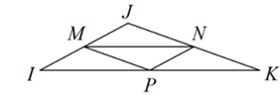(a)  (b)  (c)  (d) 

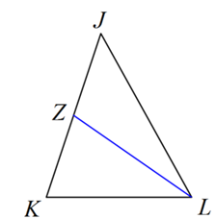

____14. Given ZL is a median, find *x* if $JK=3x-9,$ $ZL=x+4, and ZJ=x-2$.

(a) 13/2 (b)7/2 (c) 5 (d) 7

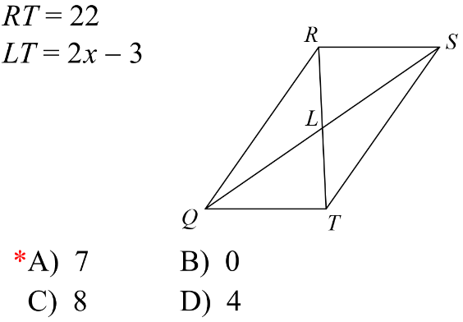____15. Given the parallelogram, solve for x.

(A) 12.5 (B) 7 (C) 11 (D) 4

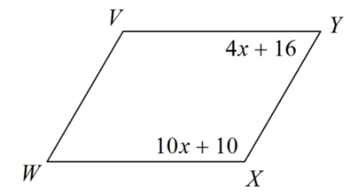_____16. Given the following parallelogram, solve for *x*.

(a) 1 (b) 11 (c) 77/3 (d) 13/7

_____17. Given the following quadrilateral, find a value for *x* that would prove it is a parallelogram.

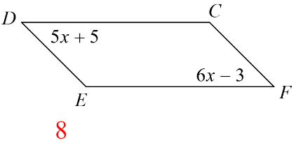 (a) 8 (b) 16.2 (c) 2 (d) 8/11

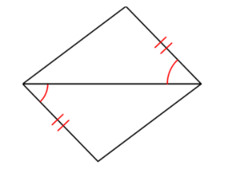_____18. State if the two triangles can be proven congruent. If so, state how you know.

(a) HL (b) SAS (c) Not Congruent (d) ASA

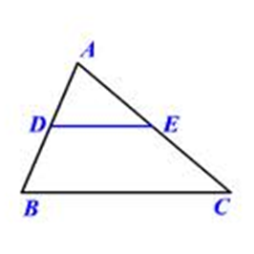

19. Given:  is a midsegment in 





Prove: 

|  |  |
| --- | --- |
| Statement | Reason |
| is a midsegment in | 1. |
|  | 2. |
|  | 3. |
|  | 4. |
|  | 5. |
|  | 6. |
|  | 7. |
|  | 8. |
|  | 9. |
|  | 10. |

**Reason Choices:** Substitution Transitive Property Given subtraction Property Midsegments are parallel to the base All angles sum to 180⁰ in a triangle

corresponding angles are congruent

20. Given: 

|  |  |
| --- | --- |
| Statement | Reason |
| 1. | Given |
| 2. | Definition of Supplementary |
| $∠2= ∠3$ | 3. |
| 4. | Substitution Property of Equality |
|  | 5. |
| $$m∥n$$ | 6. |

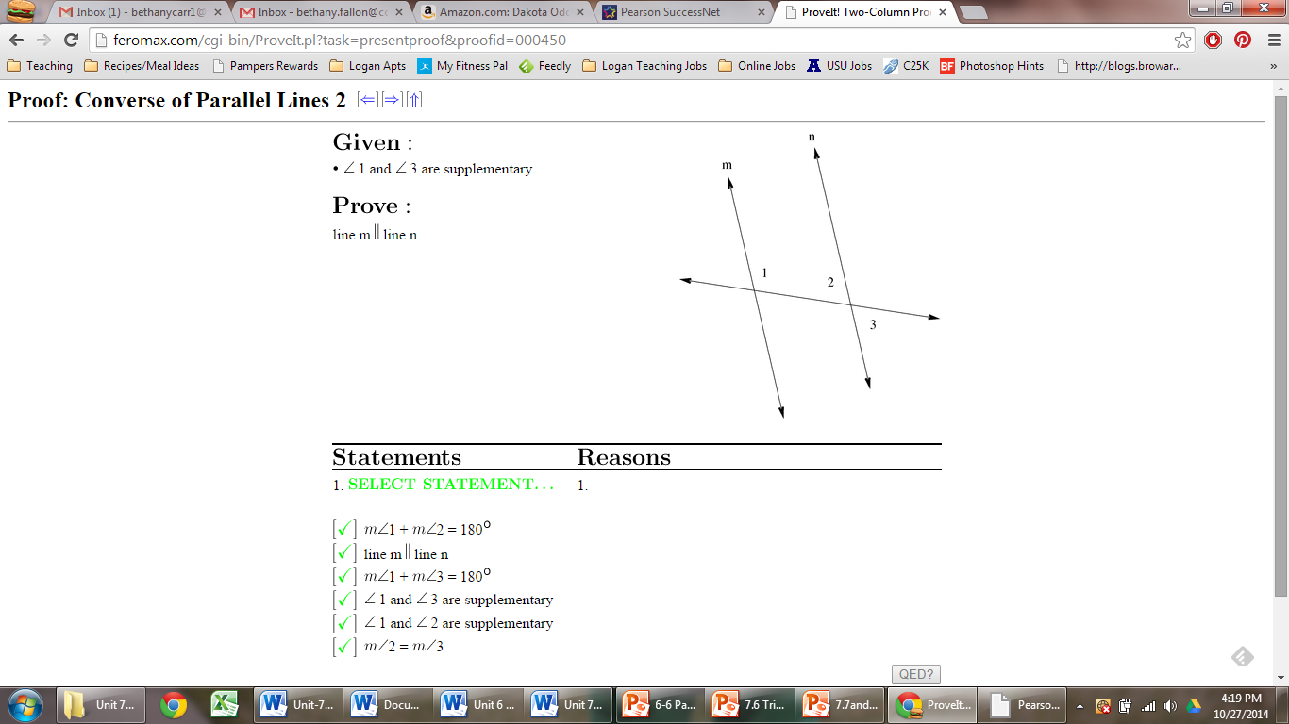 Prove: $m∥n$

**Statements: Reasons:**

a.  a. Definition of supplementary

b.  b. Vertical angles are equal in measure

c.  c. Converse of corresponding angles

d.  d. Addition property of equality

e.  e. Converse of same side interior angles

f. $∠2=∠1$ f. Same side interior angles are congruent

g.  g. Substitution property of equality

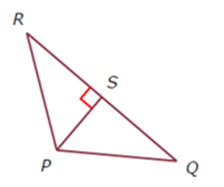

21. Given: S is the midpoint of 



Prove: 

|  |  |
| --- | --- |
| Statement | Reason |
| S is the midpoint of | 1. |
|  | 2. |
|  | 3. |
| and  are right angles | 4. |
|  | 5. |
|  | 6. |
|  | 7. |
|  | 7. |

**Reason Choices:** Right angles are congruentSubstitution Transitive Property Given CPCTC Reflexive Property of congruence Definition of a Midpoint SAS AAS SAS Definition of Perpendicular Corresponding angles are congruent Right angles are congruent

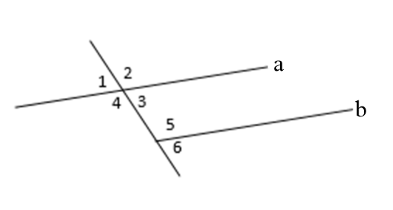

22. Given: , , 

Prove: 

|  |  |
| --- | --- |
| Statement | Reason |
| ,  , | 1. |
|  | 2. |
| 3. | Substitution property of equality |
|  | 4. |
| 5. | Subtraction property of equality |
| 6. | Division property of equality |
| 7. | Symmetric property of equality |

Statements: Reasons:

a.  a. Vertical angles are congruent

b.  b. Substitution property of equality

c.  c. Given

d.  d. Addition property of equality

e.  e. If ll lines, Same Side Interior Angles are Supplementary

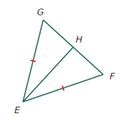 f. Subtraction property of equality

23. Given:  bisects 



Prove: 

|  |  |
| --- | --- |
| Statement | Reason |
| bisects | 1. |
|  | 2. |
|  | 3. |
|  | 4. |
|  | 5. |
|  | 6. |

**Reason Choices:** Right angles are congruentSubstitution Transitive Property Given CPCTC Reflexive Property of congruence Definition of a Midpoint SAS AAS SAS Definition of Perpendicular Definition of an angle bisector Right angles are congruent